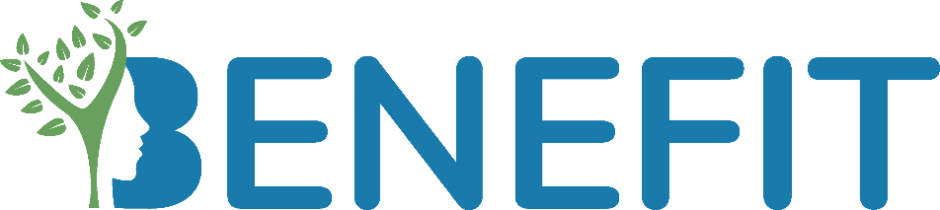

**WP5**

**News Items**

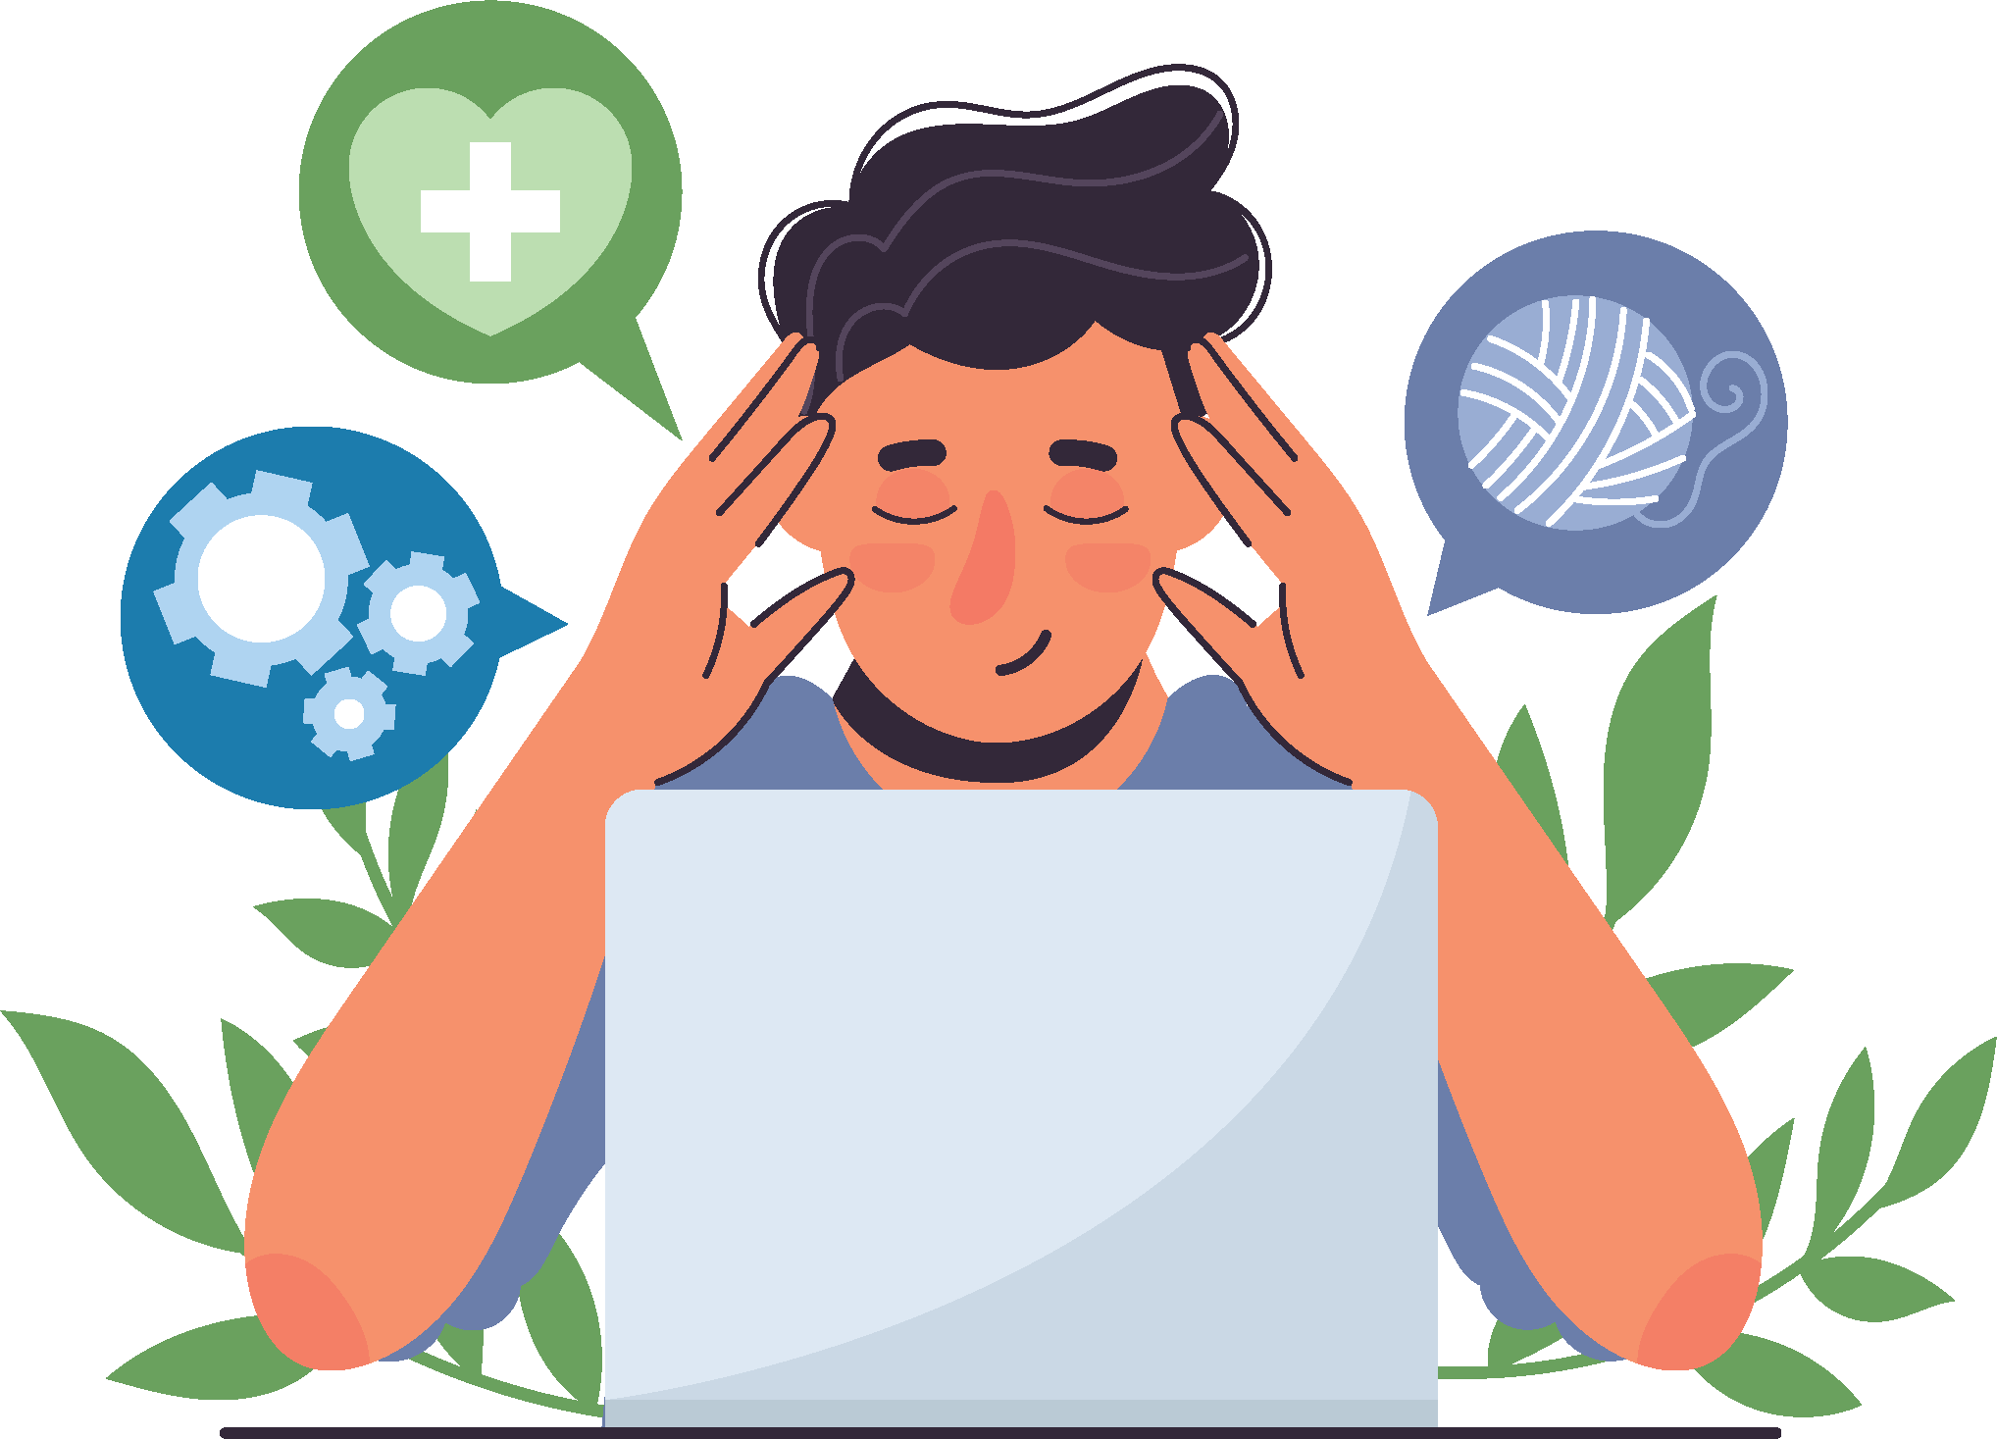

*Prepared by*

*FIP*

# Youth Mental Health and Well-Being in Ireland

In recent years, Ireland has made substantial strides in recognising the importance of mental health and well-being. This beautiful country, known for its picturesque landscapes and warm hospitality, has also shown dedication to nurturing its citizens' mental health. In this news item, we'll take a closer look at the mental health supports available in Ireland, reflecting a society that increasingly prioritises mental well-being.

Ireland boasts a range of accessible mental health services designed to cater to individuals of all ages. The Irish government, in collaboration with various mental health organisations, has expanded its efforts to ensure that anyone seeking assistance can find help when they need it. These services include both public and private options, with a focus on promoting early intervention and reducing stigma.

One of the cornerstones of Ireland's mental health support system is its community-based services. These services are easily accessible and play a crucial role in providing care and assistance to those in need. Community mental health teams, comprised of professionals such as psychiatrists, psychologists, and social workers, offer counselling, therapy, and support for individuals dealing with mental health challenges.

In the region where FIP works, for younger generation, Jigsaw Youth Mental Health Hubs are a lifeline. These centres provide mental health support and resources to young people aged 12 to 25. They offer a safe and welcoming environment where young individuals can seek assistance, attend workshops, and engage in group activities that promote mental well-being. Jigsaw Hubs are instrumental in reducing the stigma associated with youth mental health and encouraging open dialogue.

The Irish government has launched several initiatives to improve mental health services. The "Connecting for Life" strategy, for instance, focuses on reducing suicide rates and enhancing mental health support across communities. This strategy document emphasises collaboration among government agencies, health services, and local communities to create a supportive network for those in crisis.

With an array of services, both public and private, and a growing emphasis on education and awareness, Ireland is actively working to ensure that mental health is prioritised and accessible to all. This collective effort to nurture minds and change lives reflects a compassionate society dedicated to the well-being of its citizens.